**Name: Binit Banjara K210065   
Date: 17/05/2022**

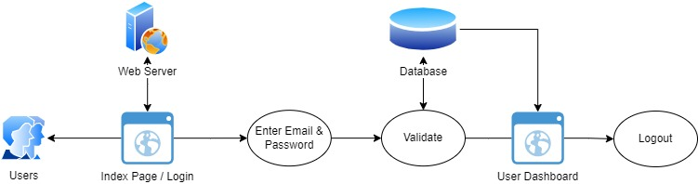

Fig: User and Admin Dashboard

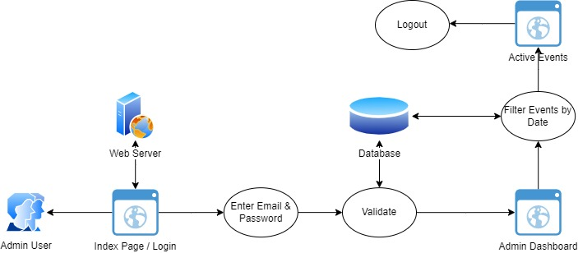

Fig: Active View

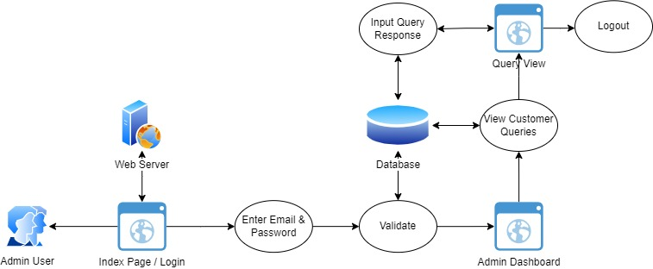

Fig: Admin Query